Dis-Asia-Russia-Lake Baikal-Malta Village-Venus Figurine- H2,1 cm x W 4,2 cm 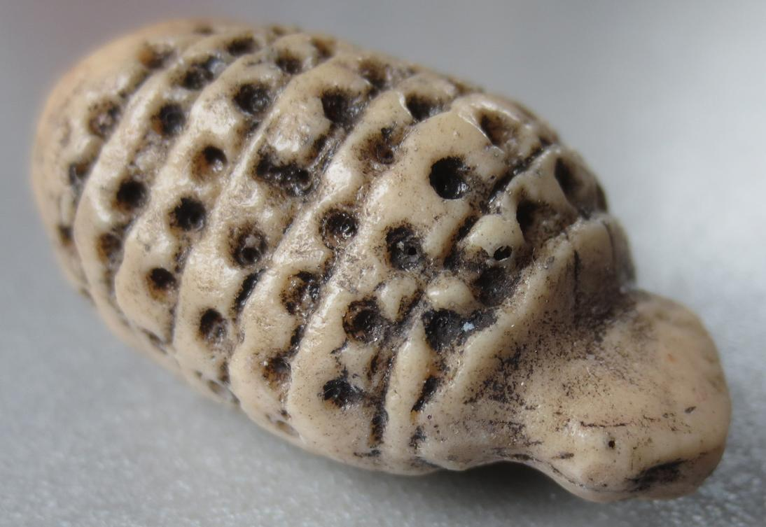

Formal Label: Venus Figurine from Lake Baikal, Malta Village, H2,1 cm x W 4,2 cm

Accession Number:

Date or Time Horizon:

Geographical Area:

Cultural Affiliation:

Media:

Dimensions: H2,1 cm x W 4,2 cm

Weight:

Provenance: